- Technical memorandum III -
to: Ed Olszewski
from: Roland Sarlot
subject: Measurement of the 90 inch primary mirror optical prescription
date: 11/1/99
cc: Gary Schmidt, Jim Burge, George Rieke, Chuck Claver, Warren Davison, John Hill, Bob Peterson
Version III changes: Pixel diameter error known, impacts uncertainty in radius of curvature.
Version II changes: Expanded error summary table, no new data is presented.

ABSTRACT
The new design of the 90” wide field prime focus corrector required the optical prescription of the primary mirror. In particular, the design was most sensitive to the conic constant. After checking the archives and opticians for records of the telescope prescription, the disagreement of data required a direct measurement of the primary. The following report details the measurements of 90 inch primary’s conic constant, radius of curvature, the physical diameter and central obscuration.

Background
The analysis of system performance of the 90 inch prime focus corrector as designed by Jim Burge required an accuracy of the primary conic to within 8% with a goal of 3%. The assumed primary optical prescription for this design is as follows: radius of 12,192.05 mm, diameter of 90.055 inches (although the common assumption has been 1 to 2 inches shorter), conic constant of –1.06 (the 90” web site lists a conic of –1.055) and central obscuration of 500 mm diameter. Gary Schmidt and Ed Olszewski researched various locations including the head optician of the primary and f/9 secondary but were not able to locate any measured data that was trustworthy and in agreement to complete the prime focus corrector design. The necessity for accurate values led to Ed’s decision to measure the primary. An interesting note is that according to the “primary mirror outline – 90 inch telescope” drawing #B-21795, the primary diameter is 90.5 inches with no shroud illustrated, this is an increase of ½ inch from the previous drawing and noted “per Univ. of Arizona print.” As another interesting note, John Hill’s dissertation listed physical dimensions of the primary taken from engineering drawings with a diameter of 229 cm (90.16”) and a focal length of 607 cm (12,140 mm).

Measurement method
After much debate, the method of conic measurement would be done by curvature sensing. With this method, the CCD is centered at best focus and moved an equal amount in ±z with images captured at both locations. The curvature sensing software solves the set of differential equations by fitting Zernike terms to the wavefront at the pupil plane by using the boundary conditions of plate scale, pupil diameter, radius of curvature of the primary and the focal ratio. The details of measuring the boundary conditions will be reported later in this report.
Warren Davison and David Dean designed a temporary spider that bolted onto the f/45 secondary spider ring that held the camera near the focal position. This method utilized four steel struts each mounted at the spider and held to each other at the base of a machining x/y translation stage. This stage held a mount that the motorized linear stage to translate the camera in z was later attached. The picture below details the three axis stage attached to the four struts with the spider ring behind Chuck.
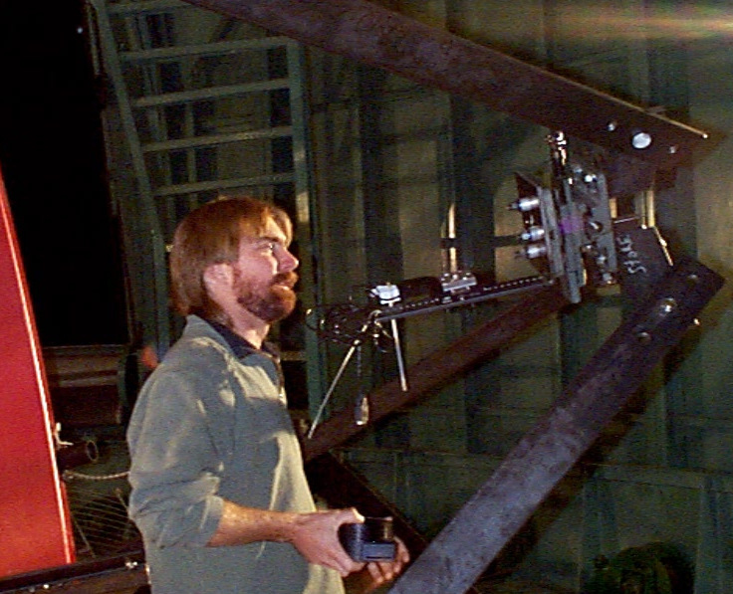

Camera Positioning
The linear actuator for this project was loaned to us by George Angeli with the drive computer, and software. The linear stage had a full 2 inches of travel. The actuator used for the test was a Newport 850F actuator on a Newport 433 linear axis stage and both were tested for linearity and repeatability by George using the distance measuring interferometer in the computer generated hologram writer at the Steward Observatory Mirror Lab. The backlash for movement was less than 7 μm with a standard deviation of 1.4 μm. Linearity was measured at better than 0.1%. The image below shows the camera in place on the linear translation stage in situ ready for data collection.
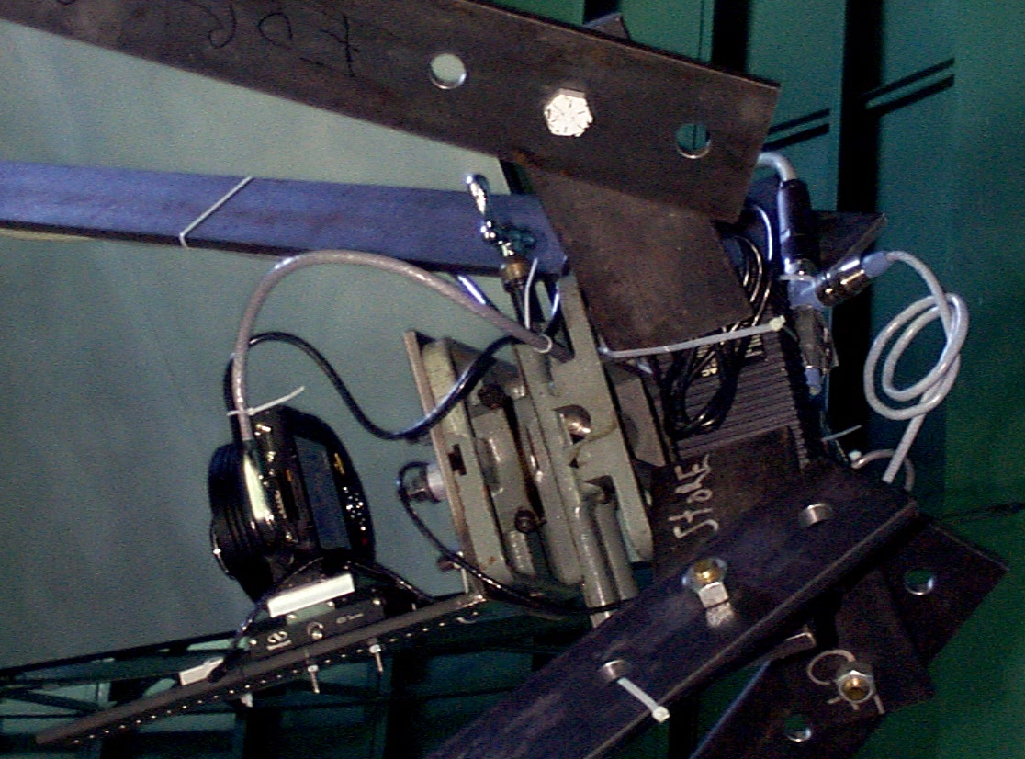

Primary Diameter
To calculate the value of the conic constant, we needed to measure the diameter of the primary. This measurement was done only once since both Chuck Claver, of the National Optical Astronomy Observatories, and I were required to stand inside the telescope cell while the telescope was in a horizontal position. We measured three points relatively equally spaced at the circumference of the mirror. These three points were marked on the 1 inch baffle that touches the primary and is the limiting aperture. The distances measured were from the mirror/baffle intersection of each point to each of its two neighboring points. The following diagram illustrates the measurement and gives the distances measured of each leg of the triangle. The “zero point” of the calibrated steel tape was ½ inch, thus the subtraction of ½ inch from each of the measurements.
Baffle
Reflective surface
A
B
Measurements
A = 6’ 6 ¾” – ½”
B = 6’ 1 7/8” – ½”
C = 6’ 10 1/16” – ½”
Central baffle/
obscuration

C

The accuracy of these three measurements are estimated better than 1/16 inch each which accounts for aligning the tape to the marked mirror edge and the sag of the tape. Therefore the diameter is calculated to be 90.00 inches ±0.0625 inches. The uncertainty is calculated if each of the legs is equally longer or shorter by 1/16 inch.
The obscuration at the center of the primary was measured by wrapping the steel tape around the circumference of the central baffle approximately 2 inches from the mirror surface (the baffle does not touch the mirrored surface.) The circumference was 105.375 inches which equates to a central obscuration of 33.542 inches in diameter. This error is probably better than 1/10 inch of diameter and is due from the baffle to mirror surface displacement.

Radius of Curvature
A field centered on the SAO star 71973 was exposed for 20 seconds. The coordinates of stars about that position in the USNO-A catalog were acquired. The IRAF task, tfinder, was used to derive a plate solution. 78 stars defined a low-order solution (2nd…3rd in IRAF lingo) with a σ of 0.2 arcseconds about the solution. The average plate scale of 0.302321 arcseconds per pixel was derived from the plate scale in x of 0.302418 and a plate scale in y of 0.302223. Using the calculated plate scale and 9 μm pixel size, the radius of curvature is then calculated at 12,280.9 mm rather than the previously assumed value of 12,192 mm. This difference of 90 mm, or 45 mm in focal length, was physically noted when the nominal position of the camera needed to be displaced one and one half inches (the additional half inch came from the stage motion) further from the mirror the night of testing corresponding with the calculated offset. The deviation about the mean magnification can be used as one measure of the uncertainty in radius of curvature. The image was 1530 x 1020 at full scale and not coadded for this computation. According to the Kodak Microelectronics Technology Division, the uncertainty in pixel diameter is on the order of 20 parts per million. The error in pixel diameter is linear with radius of curvature.

Evening of data collection
The mechanical team was present until the camera was adjusted for maximum longitudinal movement and centration. When this was complete the team of David Dean, Bob Peterson, John Waack and the daytime telescope operator left for the evening. The first task of the evening was determining the movement of the telescope relative to the movement on the image plane. Once this was complete, a very rough estimate was also known for plate scale which allowed objects to be centered in the field by communication with the telescope operator. I setup a Zemax optical design of the primary by entering the assumed physical optical prescription for the primary with the addition of a Zernike fringe phase surface at the pupil, also defined as the system stop. Chuck took six data sets, each set offset from the best focus position by 15mm and fit Zernike terms to each set. The Zernike term 11, corresponding to spherical aberration in the Laplacian software package in units of meters rms was calculated and multiplied by (1e+6 * the square root of 5) for scaling into Zemax and entered as Zernike term 9 (defined as 6p^4-6p^2+1) as fringe phase coefficients with units of wavelength set at 1 um. Zemax was allowed to optimize for best rms wavefront with two variables, one for a change in back focal distance from the marginal focus (this corresponded usually to a few microns) and the other for the conic constant. Over these six data sets the calculated conic was tracked in an Excel spreadsheet. The mean value was –1.0659 with a standard deviation of 0.0020 and a peak-to-valley spread of 0.0057. These values were within the required conic constant values needed and therefore we took an additional 5 pairs of images for later processing.

Data Reduction
The CCD used was a Santa Barbara Instrument Group model ST-8, 16 bit, 1530 x 1020 pixels with 9um pixels. No frame grabber so the pixels defined on the chip are not changed. However, for the curvature sensing, the pixels were co-added by three on the chip and processed as 27um. The curvature fitting software is from Laplacian Optics, Inc. which uses the Roddier engine for fitting. The CCD and Laplacian software was loaned and operated by Chuck.
Chuck and I empirically tested the influence of diameter and radius of curvature empirically on the conic constant. We changed the diameter from 90 inches to 90.25 inches and no influence on the Z11 term was noted (to 10 nm resolution) therefore the change in conic was imperceptible. In addition, we changed the radius of curvature value by ½% which propagated to the focal ratio. This change amounted to a change in conic of 0.0003. Note that this change in radius of curvature is greater than the uncertainty in angular separation and pixel size, both determining plate scale which directly relates to the radius of curvature.
The following conic constant results were calculated over 45 data sets and is copied from Chuck Claver’s email to Ed dated 10/5/99. Chuck copied each of the data sets’ calculated conic constant into a spreadsheet that then determined the statistics.
Mean: -1.0646
Median: -1.0645
Standard deviation: 0.00075
Variance: 5.642e-7
Standard error: 0.00011

This data was calculated with the following parameters:
Primary diameter: 90 inches
Plate scale: 33.56 ”/mm
Radius of curvature: 12,292 mm (inferred from plate scale)
Focal ratio: 2.689 (inferred from plate scale)
Linear obscuration: 0.337
Please note that these input parameters are not the exact calculated values, however, they are within the uncertainty and not significant in changing the calculated conic constant.

Analytical methods
Analytical methods can also be used to cross-check the values of the primary calculated by Zemax. Since the data for the analytical methods comes from the curvature sensing package, any possible discrepancy in plate scale, etc. will not become evident here. Jim Burge worked out two methods for calculating the conic if other data was known. One method is not possible to use since the curvature sensing software was not able to calculate focus. However, the other method follows the following equation. W₄ = (K + 1) r^4 / (8R^3) where W₄ = spherical aberration in units of length, K is the conic constant, r is the physical half diameter of the primary and R is the radius of curvature. Z₁₁ or spherical aberration term in the Laplacian package is defined as sqrt(5)*(6p^4-6p^2+1) which had an average value of –1.08 μm rms. Converting to W₄ in wavefront = sqrt(5)*6*Z11*1000 = -.01449 mm. Inserting this value of W₄ into the above equation and solving for the conic gives a value of K = -1.063, a similar value for a cross check. The difference from the measured value comes from the number of significant digits.

Error Summary
Measured parameter | Uncertainty | How known | Parameter impacted | Influence on Conic
Angular resolution of plate scale | 0.065% | Difference in x and y | Radius of curvature 0.065% | 0.000039
Pixel diameter | 20 ppm | Kodak Manufacturer | Radius of curvature | NA
Primary diameter | 0.07% | Assumption in measurement | Conic directly | NA
Obscuration diameter | 0.3% | Assumption in measurement | NA | NA
Fluctuation in conic between measurements | Standard deviation | Statistics over 45 data sets | Conic directly | 0.00075
(It was calculated that 0.3% diameter did not influence the conic, ½% error in radius of curvature changed conic by 0.0003 and the standard deviation of 45 measurements was 0.00075)

90 Inch Primary Data Summary
Conic Constant = -1.0646 ± 0.001 (rss of error summary)
Diameter = 90.00 inches ±1/16 inch
Central Obscuration diameter = 33.542 inches ±1/10 inch
Radius of Curvature = 12,280.9 mm ±4 mm
Focal ratio = 2.69

The following synthesized pattern of the primary is the optical path difference (i.e. two times the surface height errors). Removed terms are piston, tilts, focus, coma and spherical aberration. The scale is peak-to-valley of height and the initial file had course sampling of 51 x 51 pixels. The data was processed from FringeSoft Phase Mosaic. The indentation in the upper left quadrant is thought to be extraneous and caused by perhaps dust on the camera window and is not real.
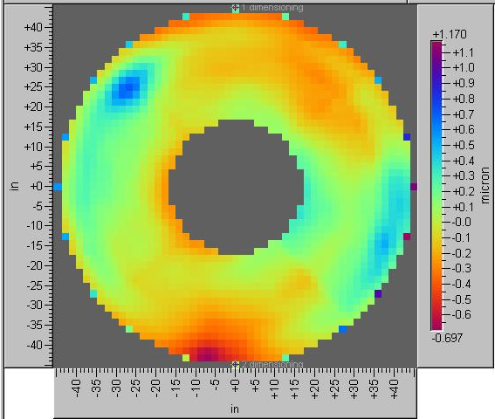

Acknowledgements
Thanks to the many people assisting on the project especially the individuals not directly related to the project who donated their energy and time. In particular, Chuck Claver of NOAO and George Angeli and Lee Dettmann from Steward Observatory.

